**ART GALLERY MANAGEMENT**

**RollNo 1939**

Index

1. About Project
2. Design
   1. ERD
   2. Use case Diagram
3. Screen shots
4. Reports

**User Side**

**Sign Up form for customer**

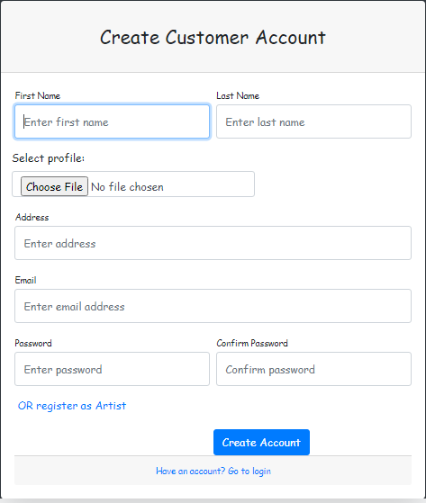

**Sign up form for Artist**

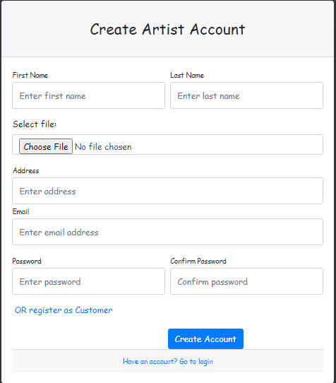

Customer Log in

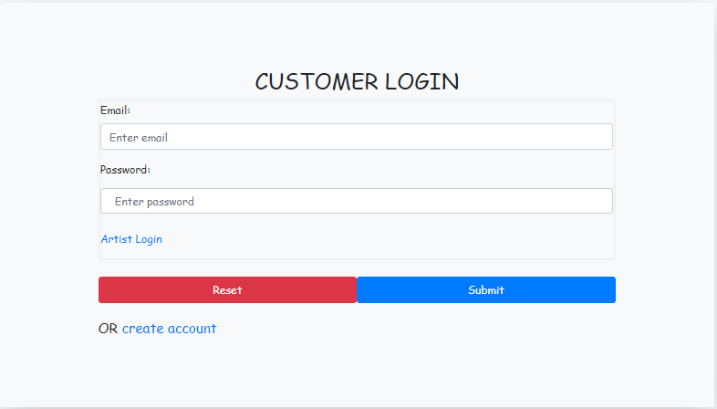

Artist Login

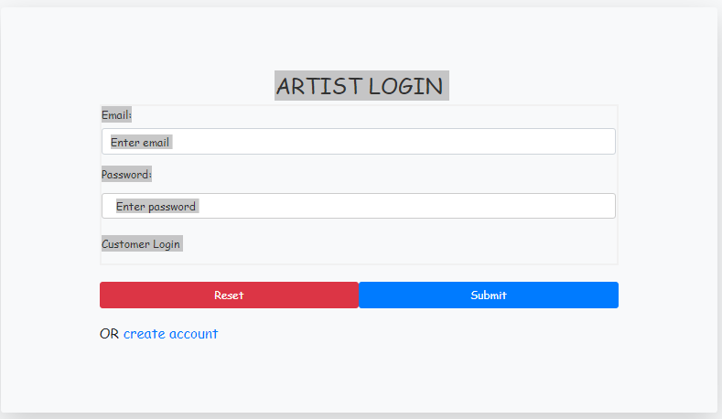

**Navigation Bar**



**Footer**



**About Us**



**Side Navigation bar**

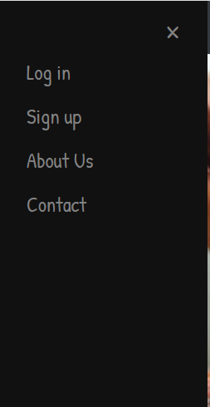

**Side Navigation bar for Artist**

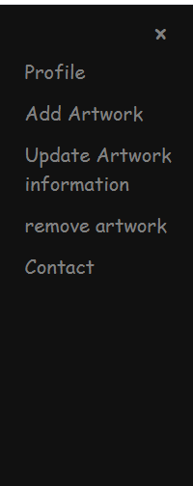

**Side navigation Bar for Customer**

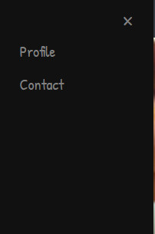

**Explore page for artist**



Explore page for customer

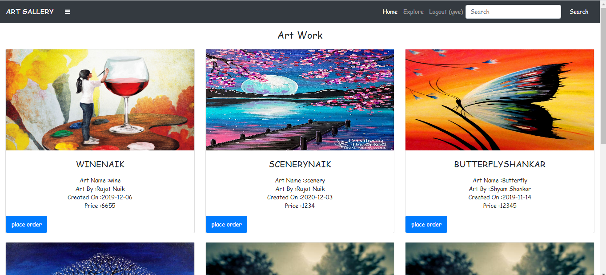

**Profile page**

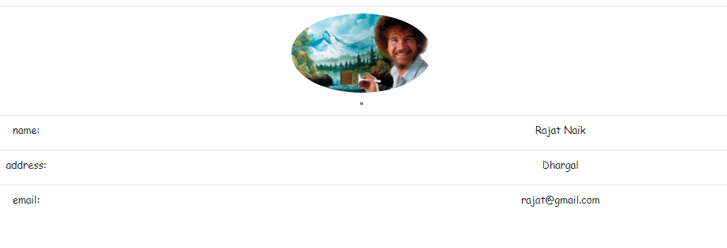

**Purchase Receipt**

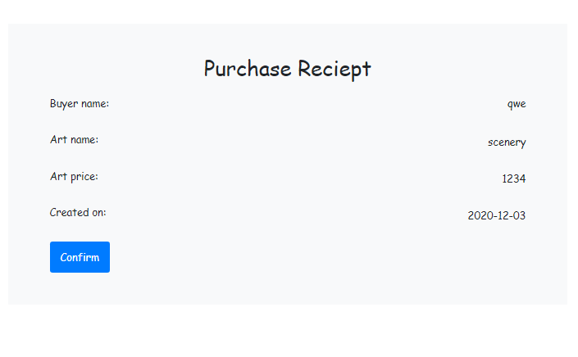

Search Results



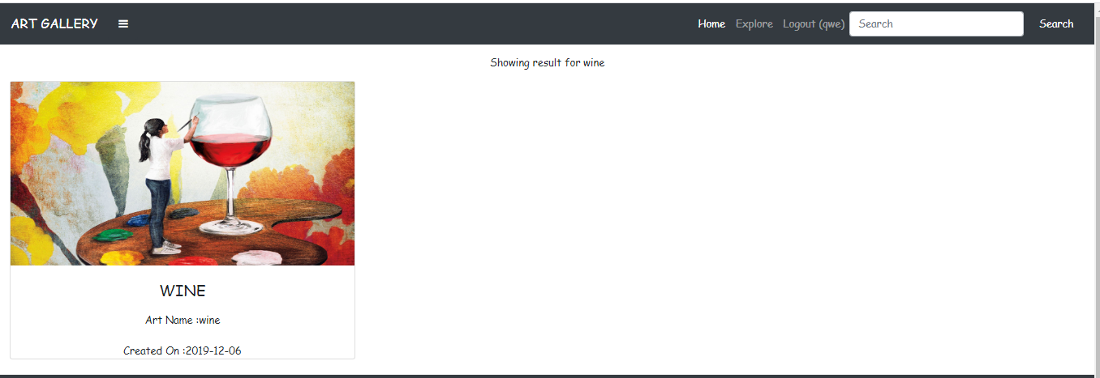

**Add Artwork**

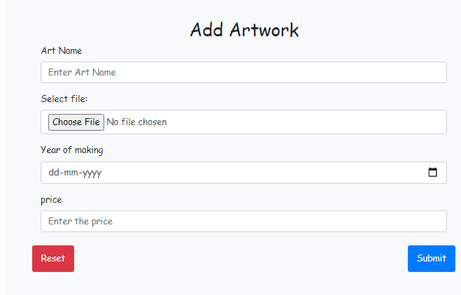

**Update Artwork**

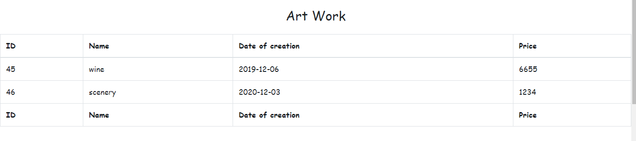

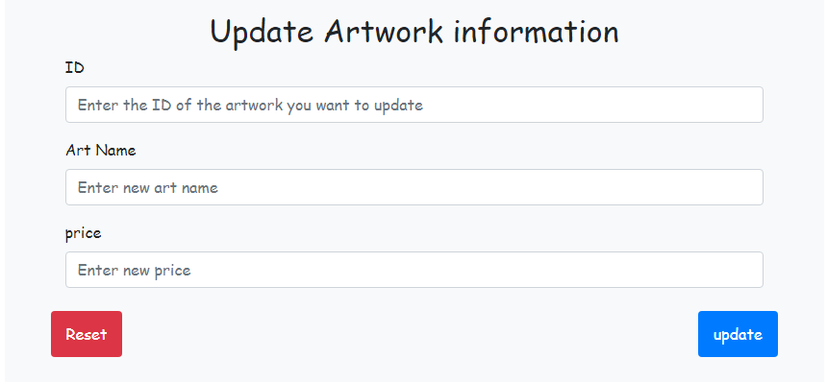

**Remove Artwork**

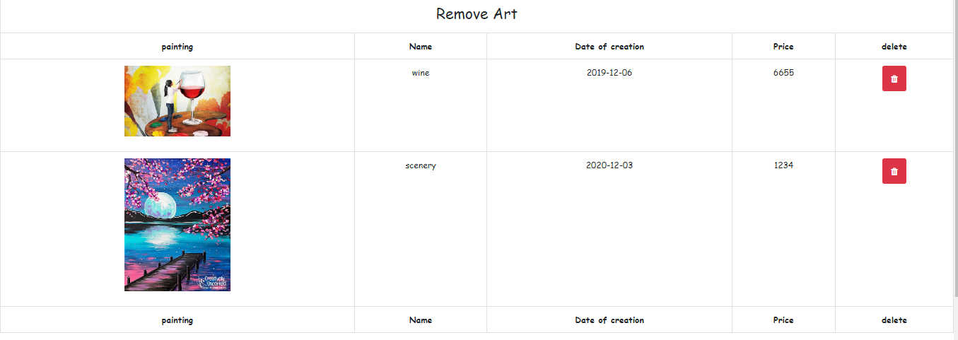

**Contact Us**

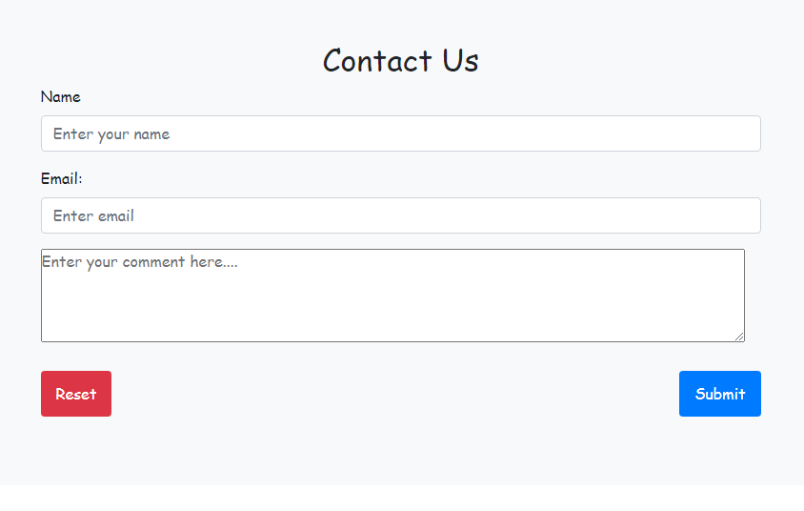

**ADMIN Side**

**Admin Login**

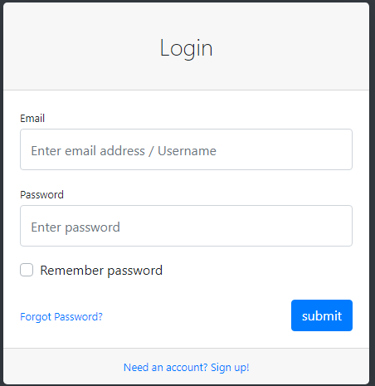

**Admin Dashboard**

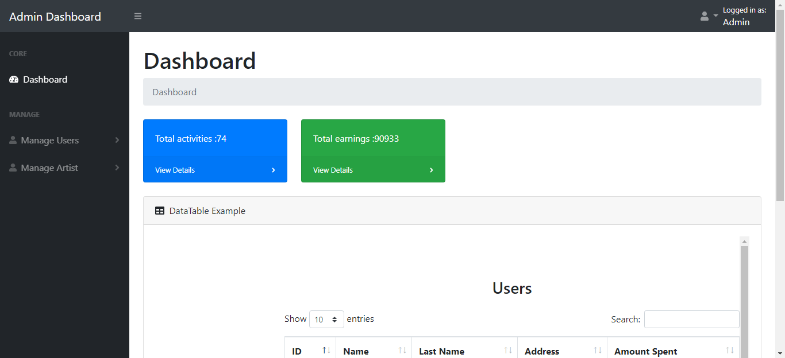

**Total Activities and profit made cards**

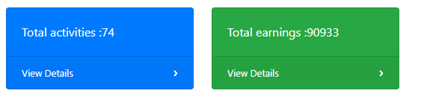

**Side Navigation Bar**



**Activity Log**

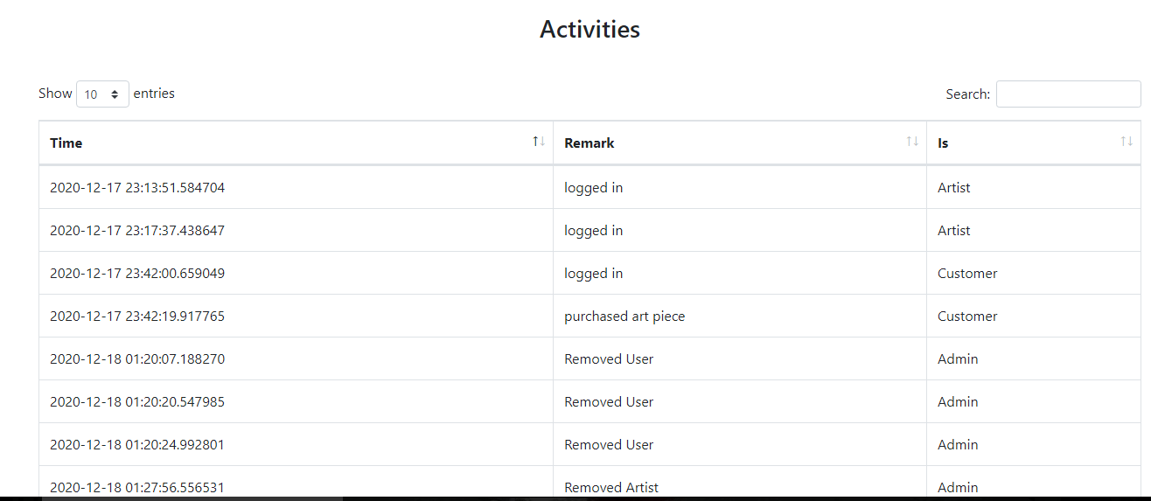

**Earnings**

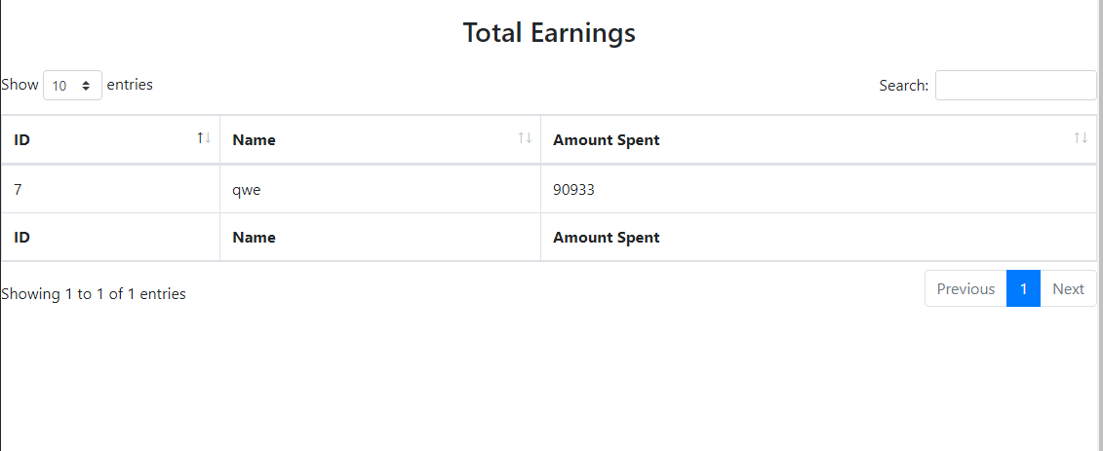

**Remove Users**

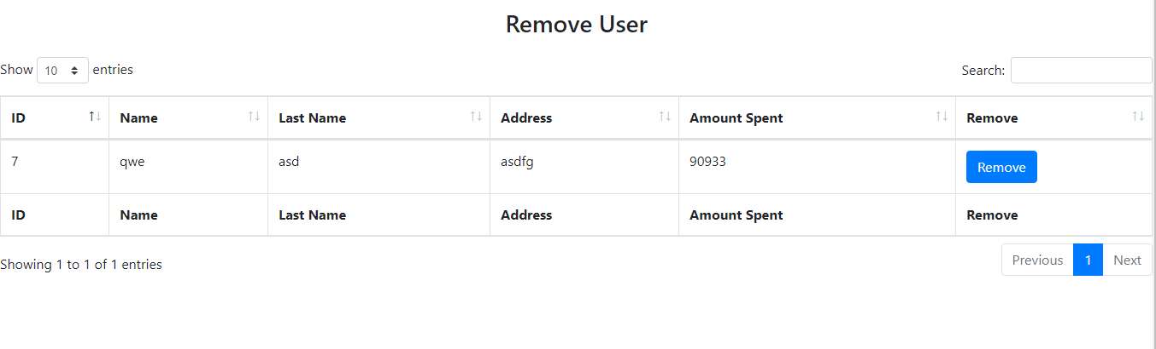

**Remove artist**

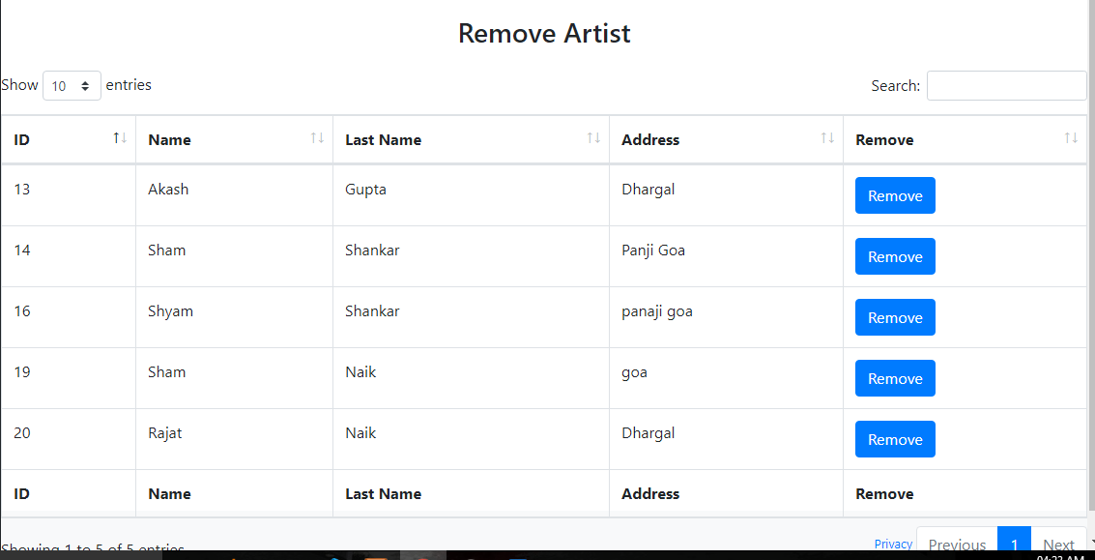

**Drop Down**

